Blockchain Assignment 15
- Write a solidity program to create a struct type with the following details-
a. Struct Name- Student
b. Input fields for Student struct-
● Name
● Age
● Roll_no
● Marks_physics
● Marks_maths
● Marks_chemistry.

c. Create a dynamic array of the student struct type and input 5 array values
from the user and return the student details when called by the array index
no.
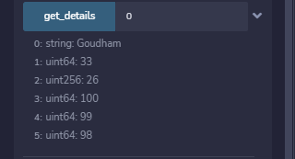

Code:
//SPDX-License-Identifier:MIT
pragma solidity ^0.8.0;

contract assign15{

struct Student {
string Name;
uint64 Age;
uint256 Roll_no;
uint64 Marks_physics;
uint64 Marks_maths;
uint64 Marks_chemistry;
}

Student[] student;

function get_details(uint64 _index) public view returns(string memory,uint64,uint256,uint64,uint64,uint64)
{
return (student[_index].Name,student[_index].Age,student[_index].Roll_no,student[_index].Marks_physics,
student[_index].Marks_maths,student[_index].Marks_chemistry);
}

function enroll(string memory _Name,uint64 _Age,uint256 _Roll_no,uint64 _Marks_physics,uint64 _Marks_maths,uint64 _Marks_chemistry) public
{
Student memory stu;
stu.Name = _Name;
stu.Age = _Age;
stu.Roll_no = _Roll_no;
stu.Marks_physics = _Marks_physics;
stu.Marks_maths = _Marks_maths;
stu.Marks_chemistry = _Marks_chemistry;
student.push(stu);

}
}

